**Binary Tree Operation**

1) Number of Nodes

• Calculate the number of nodes in the tree

• It recursively calls each subtree, adds 1 to the returned value, and returns

2) Number of Leaf Nodes

• count increases by one only when the both left and right node are NULL (= no children)

3) Height

• Recursive call to the subtree, and returns the maximum value among the return values of the subtrees

**Predecessor/Successor**

• predecessor: previous node at the traversal

• successor: next node at the traversal

-> They are defined depending on the type of traversal

**Threaded Binary Tree**

• Problem of recursive traversal in binary tree

– Recursive calls may be time-consuming for large scale tree

-> use the successor!

• Threaded binary tree

- It saves the successor in the NULL link for traversal

- Without recursive calls, we can traverse the nodes of the tree.

• Iterative inorder traversal function using thread

-Since the inorder traversal starts with the leftmost node, find the leftmost node first.

**Binary Search Tree**

- key(left subtree) ≤ key(root node) ≤ key(right subtree)

- You can get sorted values in ascending order through the inorder traversal

- Three cases

1. If the results are the same, the search ends successfully.

2. If the given value < the value of the root node, the search restarts for the left child of this root node.

3. If the given value > the value of the root node, the search restarts for the right child of this root node.

**Insertion**

• In order to insert an element into the binary search tree, it is necessary to perform the search first – The binary search tree should not contain the node with the same key value.

– The location where the search failed is the location where the new node is inserted.

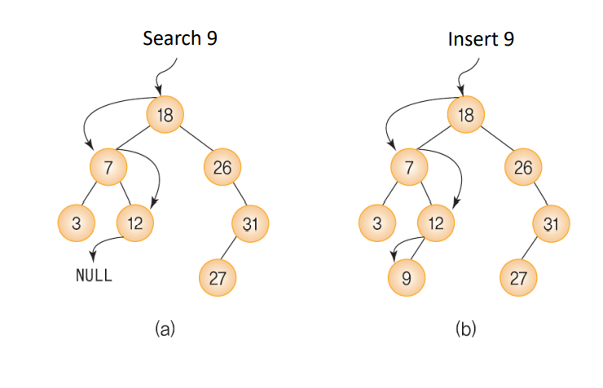

**Deletion**

Three cases

1. If the node to be deleted is a leaf node

2. If the node to be deleted has only one left or right subtree

3. If the node to be deleted has both subtrees

